UNIVERSITY OF TECHNOLOGY & EDUCATION

FACULTY FOR HIGH-QUALITY TRAINI

**Artificial Intelligent**

**RECOGNIZE 10 ANIMAL IN REAL-TIME**

**Name:Đinh Thanh Cường 19146110**

**Teacher: Ngyễn Trường Thịnh  
phone: 0909787071**



**Recognizing animals using Convolution Neural Network and camera with Google Colaboratory**

Ho Chi Minh City University of Technology and Education, Ho Chi Minh City, Vietnam

Abstract: Every day, technology advances across the world, and there is no hint that this trend will slow down in the future. Artificial Intelligence is becoming commonplace in our lives; have a peek around and discover what the AI is doing behind the scenes for you. This model was trained to detect a collection of 10 animals using a Convolution Neural Network (CNN). CNNs are utilized in image detection and processing because they are specially built to process pixel data. The majority of the data, as well as certain examples of human handwriting, were obtained over the internet and then saved on the Google Drive Cloud to provide quick access to Google Colaboratory.

1. **Introduction**

When computing is measured, the rate at which technology advances by 2x every 18 months. Big data has been created over 99 percent of the time in the previous two years. Technology's future does not appear to be slowing down but rather rising. As a result, people have a natural tendency to mix as many technologies and ideas as feasible. Multitasking with more efficiency is no longer an issue once it is integrated. This can serve as a foundation for the creation of new research.

The need for smarter technologies and devices is growing all the time nowadays. Artificial intelligence is a fantastic way to obtain human-like performance. It takes less time to do the task, and it is more accurate and sophisticated. We employ a specific sort of neural network, CNN, in this article. In at least one of its layers, it is a particular sort of artificial neural network that uses a mathematical process called convolution instead of ordinary matrix multiplication. They are employed in image recognition and processing and are specially built to handle pixel data.

1. **Description of the model**

CNNs are frequently compared to how the brain processes vision in biological creatures. In this model, we taught the AI 10 Animals letters, each with its meaning and look. Among them, some words have a similar appearance with a few more strokes, only a small adjustment to give them a different meaning.

There are 1000 photos for AI training and 999 images for model testing, the model was put through its paces 50 times. From 0 to 9, we label the 10 Animals:



*Figure 1. Labelling the 10 Animals.*

CNN model:

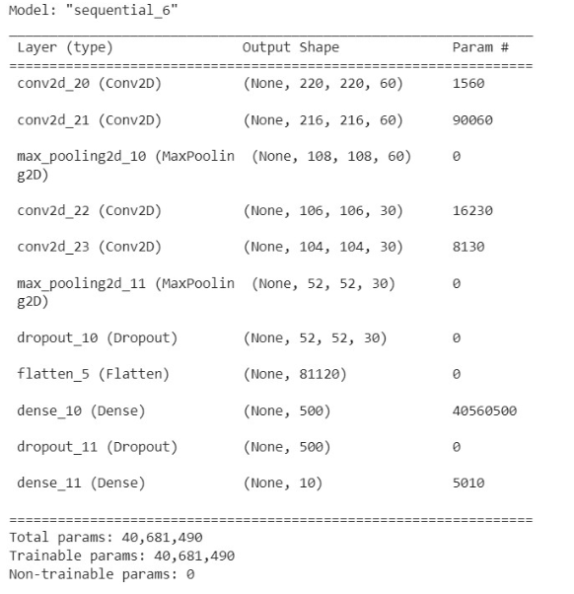

*Figure 2. Creating the CNN.*

A series of random selections in zooming, rotating, width and height shifting, brightness, and shear were added to the train data.

**3.Result**

The train was 99 per cent accurate, and the exam was 100 per cent accurate.

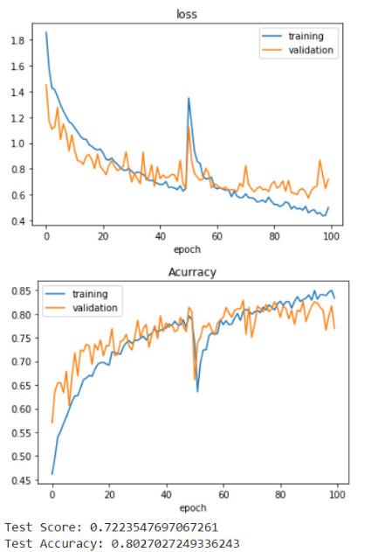

Figure 3. Model accuracy.

We put the model to the test with 10 random letters, and it accurately predicted all of them.

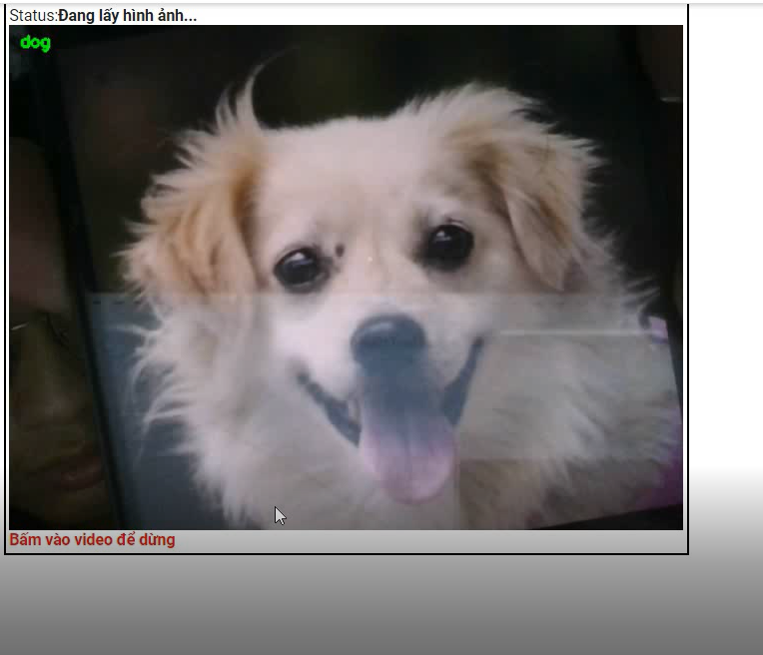

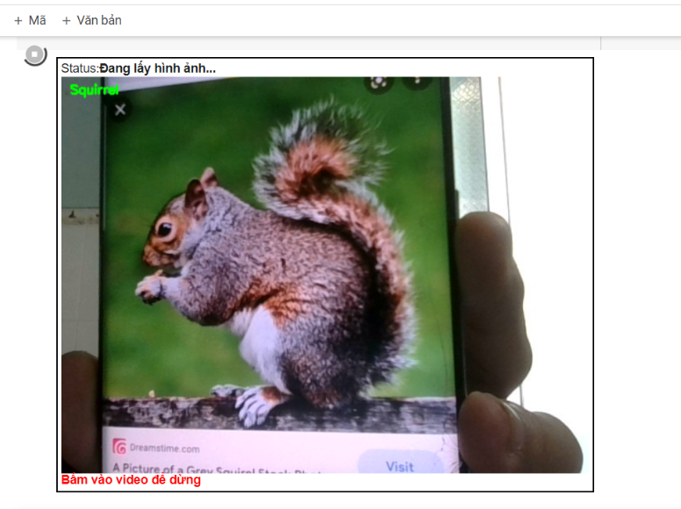

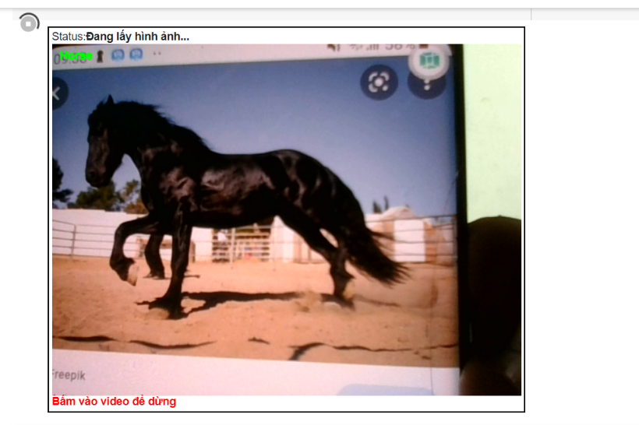

1. **Conclusions**

Even after it was enhanced, the model was a touch too tight. After 50 training sessions, it was unable to achieve 100% training. The data used to train the model was insufficient; most of it came from the internet, with a few handwritings thrown in for good measure. This was a difficulty for the model since it was unable to detect even the tiniest changes in the image. There are some awkward aspects to the process because it was run and taught on Google Colaboratory. After a while, we had to reconnect it, and when we used it to test the neural network, the GPU ran out multiple times. When we returned to finish the job, all of the files and caches had been cleared, which took a long time.

1. **Disclaimer**

The contents of this report reflect the views of the authors, who are solely responsible for the facts and the accuracy of the material and information presented herein. This report does not constitute a standard, specification or regulation.

1. **Acknowledgement**

This work was supported by Associate Prof Nguyen Truong Thinh at the Open Lab of Faculty Mechanical Engineer, Ho Chi Minh University of Technology and Education, Ho Chi Minh City, Vietnam.

1. **References**

[1] [Convolutional neural network - Wikipedia](https://en.wikipedia.org/wiki/Convolutional_neural_network)

[2] **Paul Michael**, How Fast is Technology Advancing? [Growth Charts & Statistics] 2022, MediaPeanut

[How Fast Is Technology Advancing? [Growth Charts & Statistics] 2022 (mediapeanut.com)](https://mediapeanut.com/how-fast-is-technology-growing-statistics-facts/#:~:text=The%20speed%20at%20which%20technology,only%20looks%20to%20be%20increasing.)

[3] [Artificial intelligence - Wikipedia](https://en.wikipedia.org/wiki/Artificial_intelligence)

[4] **Nguyen Ba Hung B**, Tăng cường dữ liệu trong deep learning, VIBLO ASIA

[Tăng cường dữ liệu trong deep learning (viblo.asia)](https://viblo.asia/p/tang-cuong-du-lieu-trong-deep-learning-oOVlYe4nl8W)

[5] **Nguyen Chien Thang**, Có ít dữ liệu, làm sao train model? – Chương 1. Data Augment cho ảnh, MIAI.VN

[Có ít dữ liệu, làm sao train model? - Chương 1. Data Augment - Mì AI (miai.vn)](https://www.miai.vn/2019/12/24/co-it-du-lieu-lam-sao-train-model-chuong-1-data-augment/)

[6] **The TensorFlow Authors**, l05c02_dogs_vs_cats_with_augmentation, Tensorflow

[l05c02_dogs_vs_cats_with_augmentation.ipynb - Colaboratory (google.com)](https://colab.research.google.com/github/tensorflow/examples/blob/master/courses/udacity_intro_to_tensorflow_for_deep_learning/l05c02_dogs_vs_cats_with_augmentation.ipynb?hl=vi)